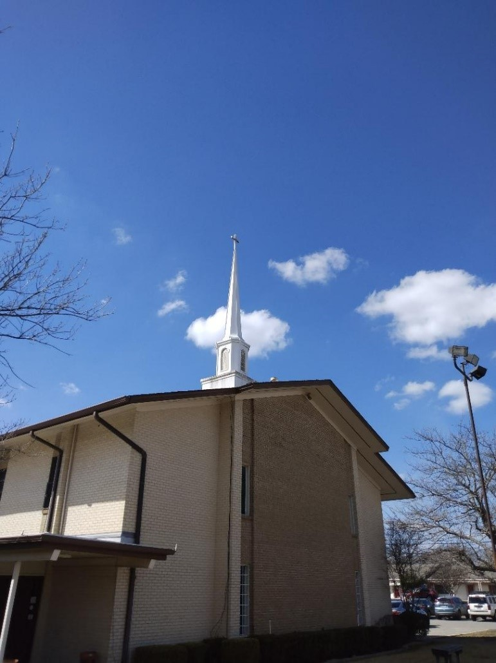

Develop your Christian faith and pursuit of academic excellence.

- AFFORDABLE TUITION

- Enrollment open
dec 27– jan 6, 2023

- Classes Begin January 9, 2023
Explore our Classes for Spring 2023!
 | spring 2022 classes  - Bible Theology I I (BT102)  - Evangelism and Missions (EM201)  - Living God’s Story (BLS 202)  - Old Testament Survey II (OTS102)  - Topics in Apologetics, Ethics & Worldview (AEW102)  - Your Work Matters to God (WM202) (7-weeks)  - Spiritual Formation & Berean Bible Lab (ME700)  - Deacon Ministry Roundtable (ME708) (7-weeks) |  | aPPLY & rEGISTER ONLINE @ WWW.DBTI.ORG  eMAIL: INFO@DBTI.ORG  PHONE: 214.328.8423  - Tuition may be paid using the Pay Pal, indicate payment is for DBTI Tuition.  0r  - Tuition may be paid by mailing a check or money order made payable to:  Dallas Bible Theological Institute  indicate payment is for DBTI Tuition  Mail to the following address:  Dallas Bible Theological Institute  8001 E. R.L. Thornton Freeway  Dallas, TX 75228

