MAR |  | OLD TESTAMENT |  |  | NEW TESTAMENT |  |  | PSALMS |  |  | PROVERBS
1 |  | LEV | 24-25 |  | LUK | 1 |  | PSA | 44:8-26 |  | PRO | 10:20-21
2 |  | LEV | 26 |  | LUK | 2 |  | PSA | 45 |  | PRO | 10:22
3 |  | LEV | 27 |  | LUK | 3 |  | PSA | 46 |  | PRO | 10:23
`4 |  | NUM | 1-3 |  | PRAISE |  |  | PSA | 47 |  | PRO | 10:24-25
5 |  | NUM | 4-5 |  | LUK | 4 |  | PSA | 48 |  | PRO | 10:26
6 |  | NUM | 6-7 |  | LUK | 5 |  | PSA | 49 |  | PRO | 10:27-28
7 |  | NUM | 8-9 |  | PRAISE |  |  | PSA | 50 |  | PRO | 10:29-30
8 |  | NUM | 10-11 |  | LUK | 6 |  | PSA | 51 |  | PRO | 10:31-32
9 |  | NUM | 12-13 |  | LUK | 7 |  | PSA | 52 |  | PRO | 11:1-3
10 |  | NUM | 14 |  | LUK | 8 |  | PSA | 53 |  | PRO | 11:4
11 |  | NUM | 15 |  | LUK | 9 |  | PSA | 54 |  | PRO | 11:5-6
12 |  | NUM | 16-17 |  | PRAISE |  |  | PSA | 55 |  | PRO | 11:7
13 |  | NUM | 18 |  | LUK | 10 |  | PSA | 56 |  | PRO | 11:8
14 |  | NUM | 19-20 |  | LUK | 11 |  | PSA | 57 |  | PRO | 11:9-11
15 |  | NUM | 21-22 |  | PRAISE |  |  | PSA | 58 |  | PRO | 11:12-13
16 |  | NUM | 23 |  | LUK | 12 |  | PSA | 59 |  | PRO | 11:14
17 |  | NUM | 24-25 |  | LUK | 13 |  | PSA | 60 |  | PRO | 11:15
18 |  | NUM | 26-27 |  | LUK | 14 |  | PSA | 61 |  | PRO | 11:16-17
19 |  | NUM | 28-29 |  | LUK | 15 |  | PSA | 62 |  | PRO | 11:18-19
20 |  | NUM | 30-31 |  | LUK | 16 |  | PSA | 63 |  | PRO | 11:20-21
21 |  | NUM | 32-33 |  | PRAISE |  |  | PSA | 64 |  | PRO |  | 11:22
22 |  | NUM | 34 |  | LUK | 17 |  | PSA | 65 |  | PRO | 11:23
23 |  | NUM | 35-36 |  | LUK | 18 |  | PSA | 66 |  | PRO | 11:24-25
24 |  | DEU | 1-2 |  | LUK | 19 |  | PSA | 67 |  | PRO | 11:26-27
25 |  | DEU | 3-4 |  | LUK | 20 |  | PSA | 68:1-18 |  | PRO | 11:28-29
26 |  | DEU | 5-6 |  | PRAISE |  |  | PSA | 68:19-35 |  | PRO | 11:30-31
27 |  | DEU | 7-8 |  | LUK | 21 |  | PSA | 69:1-14 |  | PRO | 12:1
28 |  | DEU | 9-10 |  | LUK | 22 |  | PSA | 69:15-36 |  | PRO | 12:2-3
29 |  | DEU | 11-12 |  | LUK | 23 |  | PSA | 70 |  | PRO | 12:4-5
30 |  | DEU | 13-15 |  | LUK | 24 |  | PSA | 71 |  | PRO | 12:6-7
31 |  | DEU | 16-17 |  | PRAISE |  |  | PSA | 72 |  | PRO | 12:8-9



“Now the Bereans were of more noble character
than the Thessalonians, for they received the message with great
eagerness and examined the Scriptures every day to see if what
Paul said was true.” Acts 17:11 (NIV)

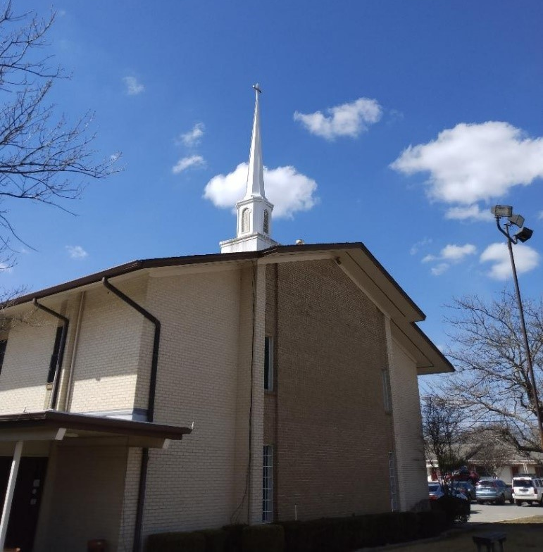

All Scripture is God-breathed and is useful for teaching, rebuking, correcting and training in righteousness.” 2Timothy 3:16

JAN |  | OLD TESTAMENT |  |  | NEW TESTAMENT |  |  |  |  | PSALMS |  |  | PROVERBS
1 |  | GEN | 1-2 |  | MAT | 1 |  |  |  | PSA | 1 |  | PRO | 1:1-6
2 |  | GEN | 3-4 |  | MAT | 2 |  |  |  | PSA | 2 |  | PRO | 1:7-9
3 |  | GEN | 5-7 |  | MAT | 3 |  |  |  | PSA | 3 |  | PRO | 1:10-19
4 |  | GEN | 8-10 |  | MAT | 4 |  |  |  | PSA | 4 |  | PRO | 1:20-23
5 |  | GEN | 11-13 |  | MAT | 5 |  |  |  | PSA | 5 |  | PRO | 1:24-28
6 |  | GEN | 14-15 |  | MAT | 6 |  |  |  | PSA | 6 |  | PRO | 1:29-33
7 |  | GEN | 16-17 |  | MAT | 7 |  |  |  | PSA | 7 |  | PRO | 2:1-5
8 |  | GEN | 18-19 |  | MAT | 8 |  |  |  | PSA | 8 |  | PRO | 2:6-15
9 |  | GEN | 20-22 |  | MAT | 9 |  |  |  | PSA | 9:1-12 |  | PRO | 2:16-22
10 |  | GEN | 23-24 |  | MAT | 10 |  |  |  | PSA | 9:13-20 |  | PRO | 3:1-6
11 |  | GEN | 25 |  | MAT | 11 |  |  |  | PSA | 10:1-15 |  | PRO | 3:7-8
12 |  | GEN | 26-27 |  | PRAISE |  |  |  |  | PSA | 10:16-18 |  | PRO | 3:9-10
13 |  | GEN | 28-29 |  | MAT | 12 |  |  |  | PSA | 11 |  | PRO | 3:11-12
14 |  | GEN | 30-31 |  | MAT | 13 |  |  |  | PSA | 12 |  | PRO | 3:13-15
15 |  | GEN | 32 |  | MAT | 14 |  |  |  | PSA | 13 |  | PRO | 3:16-18
16 |  | GEN | 33-34 |  | MAT | 15 |  |  |  | PSA | 14 |  | PRO | 3:19-20
17 |  | GEN | 35-36 |  | MAT | 16 |  |  |  | PSA | 15 |  | PRO | 3:21-26
18 |  | GEN | 37-38 |  | MAT | 17 |  |  |  | PSA | 16 |  | PRO | 3:27-32
19 |  | GEN | 39-4O |  | MAT | 18 |  |  |  | PSA | 17 |  | PRO | 3:33-35
20 |  | GEN | 41 |  | MAT | 19 |  |  |  | PSA | 18:1-15 |  | PRO | 4:1-6
21 |  | GEN | 42-43 |  | PRAISE |  |  |  |  | PSA | 18:16-34 |  | PRO |  | 4:7-10
22 |  | GEN | 44-45 |  | MAT | 20 |  |  |  | PSA | 18:35-20 |  | PRO | 4:11-13
23 |  | GEN | 46-47 |  | MAT | 21 |  |  |  | PSA | 19 |  | PRO | 4:14-19
24 |  | GEN | 48-49 |  | MAT | 22 |  |  |  | PSA | 20 |  | PRO | 4:20-27
25 |  | GEN | 50 |  | MAT | 23 |  |  |  | PSA | 21 |  | PRO | 5:1-6
26 |  | EXO | 1-3 |  | MAT | 24 |  |  |  | PSA | 22:1-18 |  | PRO | 5:7-14
27 |  | EXO | 4-5 |  | MAT | 25 |  |  |  | PSA | 22:19-31 |  | PRO | 5:15-21
28 |  | EXO | 6-7 |  | MAT | 26 |  |  |  | PSA | 23 |  | PRO | 5:22-23
29 |  | EXO | 8-9 |  | MAT | 27 |  |  |  | PSA | 24 |  | PRO | 6:1-5
30 |  | EXO | 10-11 |  | MAT | 28 |  |  |  | PSA | 25:1-11 |  | PRO | 6:6-11
31 |  | EXO | 12-13 |  | PRAISE |  |  |  |  | PSA | 25:12-22 |  | PRO | 6:12-15
FEB |  | OLD TESTAMENT |  |  | NEW TESTAMENT |  |  |  |  | PSALMS |  |  | PROVERBS
1 |  | EXO | 14-15 |  | MAR | 1 |  |  |  | PSA | 26:1-12 |  | PRO | 6:16-19
2 |  | EXO | 16-17 |  | MAR | 2 |  |  |  | PSA | 27:1-7 |  | PRO | 6:20-26
3 |  | EXO | 18-19 |  | PRAISE |  |  |  |  | PSA | 27:8-14 |  | PRO | 6:27-35
4 |  | EXO | 20-21 |  | MAR |  |  | 3 |  | PSA | 28 |  | PRO | 7:1-5
5 |  | EXO | 22-23 |  | MAR |  | 4 |  |  | PSA | 29 |  | PRO | 7:6-23
6 |  | EXO | 24-25 |  | PRAISE |  |  |  |  | PSA | 30 |  | PRO | 7:24-27
7 |  | EXO | 26-27 |  | MAR |  | 5 |  |  | PSA | 31:1-8 |  | PRO | 8:1-11
8 |  | EXO | 28 |  | MAR | 6 |  |  |  | PSA | 31:9-18 |  | PRO | 8:12-13
9 |  | EXO | 29-30 |  | PRAISE |  |  |  |  | PSA | 31:19-24 |  | PRO | 8:14-26
10 |  | EXO | 31 |  | MAR | 7 |  |  |  | PSA | 32 |  | PRO | 8:27-32
11 |  | EXO | 32-33 |  | PRAISE |  |  |  |  | PSA | 33:1-11 |  | PRO | 8:33-36
12 |  | EXO | 34-35 |  | MAR | 8 |  |  |  | PSA | 33:12-22 |  | PRO | 9:1-6
13 |  | EXO | 36 |  | PRAISE |  |  |  |  | PSA | 34:1-10 |  | PRO | 9:7-8
14 |  | EXO | 37-38 |  | MAR | 9 |  |  |  | PSA | 34:11-22 |  | PRO | 9:9-10
15 |  | EXO | 39-40 |  | PRAISE |  |  |  |  | PSA | 35:1-16 |  | PRO | 9:11-12
16 |  | LEV | 1-3 |  | MAR |  | 10 |  |  | PSA | 35:17-28 |  | PRO | 9:13-18
17 |  | LEV | 4-5 |  | PRAISE |  |  |  |  | PSA | 36 |  | PRO | 10:1-2
18 |  | LEV | 6-7 |  | MAR | 11 |  |  |  | PSA | 37:1-11 |  | PRO | 10:3-4
19 |  | LEV | 8-9 |  | PRAISE |  |  |  |  | PSA | 37:12-28 |  | PRO | 10:5
20 |  | LEV | 10 |  | MAR | 12 |  |  |  | PSA | 37:29-40 |  | PRO | 10:6-7
21 |  | LEV | 11-12 |  | PRAISE |  |  |  |  | PSA | 38 |  | PRO |  | 10:8-9
22 |  | LEV | 13 |  | MAR | 13 |  |  |  | PSA | 39 |  | PRO | 10:10
23 |  | LEV | 14 |  | PRAISE |  |  |  |  | PSA | 40:1-10 |  | PRO | 10:11-12
24 |  | LEV | 15-16 |  | MAR |  | 14 |  |  | PSA | 40:11-17 |  | PRO | 10:13-14
25 |  | LEV | 17-18 |  | PRAISE |  |  |  |  | PSA | 41 |  | PRO | 10:15-16
26 |  | LEV | 19-20 |  | MAR | 15 |  |  |  | PSA | 42 |  | PRO | 10:17
27 |  | LEV | 21-22 |  | PRAISE |  |  |  |  | PSA | 43 |  | PRO | 10:18
28 |  | LEV | 23 |  | MAR | 16 |  |  |  | PSA | 44 |  | PRO | 10:19
“This Book of the Law shall not depart from your mouth, but you shall meditate in it day and night, that you may observe to do according to all that is written in it. For then you will make your way prosperous, and then you will have good success.
Joshua 1:8

